

CRAIGIEBUCKLER & SEAFIELD Community Council Report

This report covers progress we have made in dealing with your priorities for the Craigiebuckler & Seafield Community Council for June 2021.
The report aims to highlight emerging issues in your area, and to provide crime prevention advice and guidance to Community Council members and residents you represent. Our focus is to reduce crime and disorder, help create safer communities and respond effectively to local concerns.

COVID 19 – UPDATE

As of Saturday 5th June 2021 Aberdeen City moved to Level 1 of the 5 Covid-19 protection levels laid out by the Scottish Government. The Scottish Governments intention is for most of Scotland (not already at Level 1) to move to Level 0 on 19th July and all remaining restrictions removed from the 9th August, but only if the data remains supportive and the restrictions in the levels remain necessary and proportionate.
The below link is what can & cannot be done in Level 1.
https://www.gov.scot/publications/coronavirus-covid-19-protection-levels/pages/protection-level-1/
Remember FACTS to help protect yourselves and others:
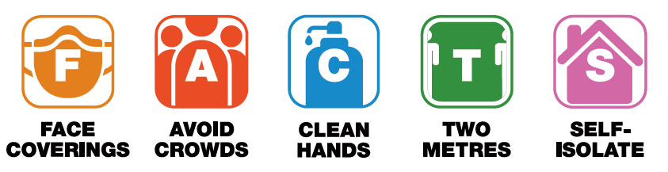

Officers continue to respond to reports of any breaches in the regulations using the 4E’s principle, namely Engage, Explain Encourage and Enforce as a last resort. Locally Police received a single call which on investigation revealed no breach in the regulations being committed.

Community Policing Priorities

Antisocial behaviour, Violence and Disorder:
This month officers continue to patrol areas known for anti-social behaviour and includes Hazelhead Park, Groats Road and the surrounding area.

About 1935 hours on Saturday 19th June, Scottish Fire and Rescue Service attended and extinguished an unattended fire within the wooded area approximately 300 yards from Somebody Cares building which was deemed to be wilful. Police also attended and are making enquiries into the incident. Anyone with information is asked to contact Police on 101 quoting incident 3631 of the 19th June.

On Wednesday 23rd June, a group of youths have been seen causing damage to fence surrounding the Astro Turf pitch at Hazelhead Academy. Officers are following a positive line of enquiry in relation to this incident.

As the weather continues to improve we are seeing more people out enjoying the outdoor spaces. I continue to encourage everyone to be respectful of others and act responsibly, so that we can each enjoy what our local area has to offer.

Acquisitive Crime:
Between Monday 31st May and Wednesday 2nd June, on Queens Crescent, parts of a secured pedal cycle were stolen. Anyone with information is asked to contact Police on 101 quoting incident 3852 of the 2nd June.

Please remain vigilant of anyone acting suspiciously and report this to police passing as much detail as possible. Please keep belongings safe and secure, preferably out of sight. If anything can be removed easily such as pedal cycle wheels/seats (quick release) please ensure these are secured or removed prior to leaving unattended.

Road Safety & Road Crime:
There have been no incidents of note over the reporting period.

We continue to work with partners in response to specific complaints in terms of road traffic offences and to make use of antisocial behaviour legislation. Residents in the areas affected by antisocial driving are encouraged to contact Police on 101 at the time, to report incidents and provide as much description as possible of the vehicle(s)/person(s) in order for us to take positive action.

Community Engagement & Reassurance
Campaign launched to tackle summer cycling casualties | Get About

On the 14th June 2021 partners across the North East have launched a collective campaign that aims to reduce higher incidents of cycling casualties over the summer months.
Research has shown an increase in local pedal cycle casualties during the summer months, as pedal cyclists get out on two wheels across North East Scotland.
Records show that in many of the cases, a common cause of the incident was that either the driver or rider ‘failed to look properly’. The campaign seeks to remind cyclists and drivers alike to pay attention to one another, particularly at critical decision-making moments such as junctions and roundabouts, and highlights this during the peak season for these incidents.
The campaign will be supported by police patrols on key cycling routes, as well as officers working in communities near collision hotspots.
In addition, the North Safety Camera Unit will continue to carry out speed enforcement on key routes as part of their ongoing work over the summer.
While the trend for higher cycling incidents over the summer is not unique to the North East, local partners are continuing to work to reduce the number and severity of all casualties, moving towards a vision of zero fatalities on the road network.
Locally officers will be out engaging with local road users across the Community taking the opportunity to educate all road users and where necessary deal with any road traffic offences in a proportionate manner.

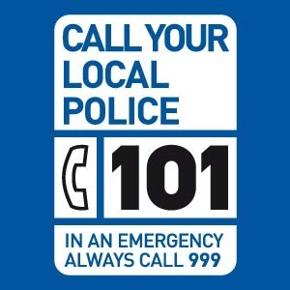

Follow us on Twitter @NorthEPolice #HazleheadCPT

Also available are the three following contact email addresses for the Hazlehead Policing team:

HazleheadAshleyQueensCrossCPT@Scotland.pnn.police.uk
LowerDeesideCPT@Scotland.pnn.police.uk
KingswellSheddocksleyCPT@Scotland.pnn.police.uk

The primary purpose of these e-mail addresses is for residents to report non-criminal queries, such as passing attentions, information, advice and non-criminal quality of life issues, such as youth annoyance. These e-mail addresses are not for reporting crimes or offences. The process for reporting any crimes or offences is to call 101, where our Service Centre will log the call on our Command and Control system and allocate the incident to our area. Using this process negates the possibility of the report being missed and also ensures that the caller’s details, addresses and telephone numbers are noted for our awareness and response.

Should you have any concerns or questions, please do not hesitate to discuss these with the Officer attending your Community Council Meeting or by emailing the above e-mail addresses or our Service Centre. It is not necessary to wait until the meeting and your local CPT Inspector, PI Sim welcomes your contact.

Contact Us

Please also remember you can communicate with us using any of the following:

-  101 – Non emergency;
-  Twitter - @NorthEPolice;
-  Facebook – www.facebook.com/NorthEastPoliceDivision;
-  Web – www.scotland.police.uk;
-  999 – Emergency;
-  0800 555 111 - Crimestoppers.

