Craigiebuckler & Seafield Community Council
Statement of Accounts January 01 to December 31 2024
Closing Balance at 23/12/2023 £963.88 end of the Financial Year 01/01 – 31/12/2023

Opening Balance £963.88 01/01/2024

Paid In Paid Out
Date: 26/02/2024 Chq.No.010159
ACC Payment for Christmas lights £300.00
Balance at 15/03/24 was £663.88
Date: 02/05/24 BGC CCA276216 £1077.54
Received from: AAC Grant
Balance at 02/05/2024 £1741.22
Date: 09/05/2024 Chq.No.01061 £097.20
Recipient: William Sell – Reimbursement for Zoom annual fee
Date: 30/05/2024 Chq.No.010162 £030.00
Recipient: Catherine Mackay – Honorarium
Date: 11/06.2024 Chq.No.010163 £032.18
Recipient: Cameron Campbell – reimbursement for Dog Bags
Date: 31/07/2024 DD ICO ZA430010 £035.00
Recipient: Zurich ICO GDPR Data Protection
Date: 23/12/2024 FPO 82601110 £300.00
Recipient: Aberdeen City Council Christmas Lighting
Date: 23/12/2023 FPO 82701510 £250.00
Recipient: Aberdeen Springfield Church Festival of Light event
Closing Balance 23/12/2024 £997.04 end of the Financial Year 01/01/24 – 31/12/24
PAID IN
For noting (1):
Donation by Malcolm Allan Housebuilders Ltd:
Date: 11/02/25 Electronic payment FPI £300.00
To reimburse C&S CC for Christmas Lights on Springfield Road paid through an FPI COM73349733554116F7SW40516210
Current balance on 04/03/2024: £1297.04
For noting (2):
Agreed sums approved for payment in March 2025
i) Girl Guides Springfield Church group £100.00
ii) Boys Brigade Springfield Church group £100.00
iii) Boy Scouts Craigiebuckler group £100.00

Signed as a true record Cameron Campbell - Treasurer 03/03/2025.
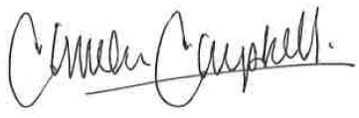
On behalf of Craigiebuckler & Seafield Community Council Independently

Audited: Ms Catherine Mackay
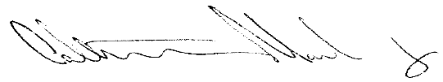
Finance Administrator, Gray’s School of Art, The Robert Gordon University, Garthdee, Aberdeen AB10 7QD Signed:
Date: 04/03/25

